Volunteer Handbook
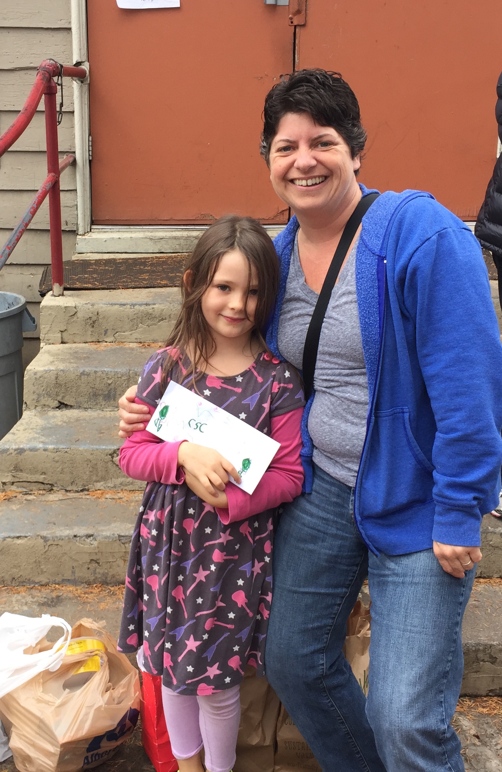
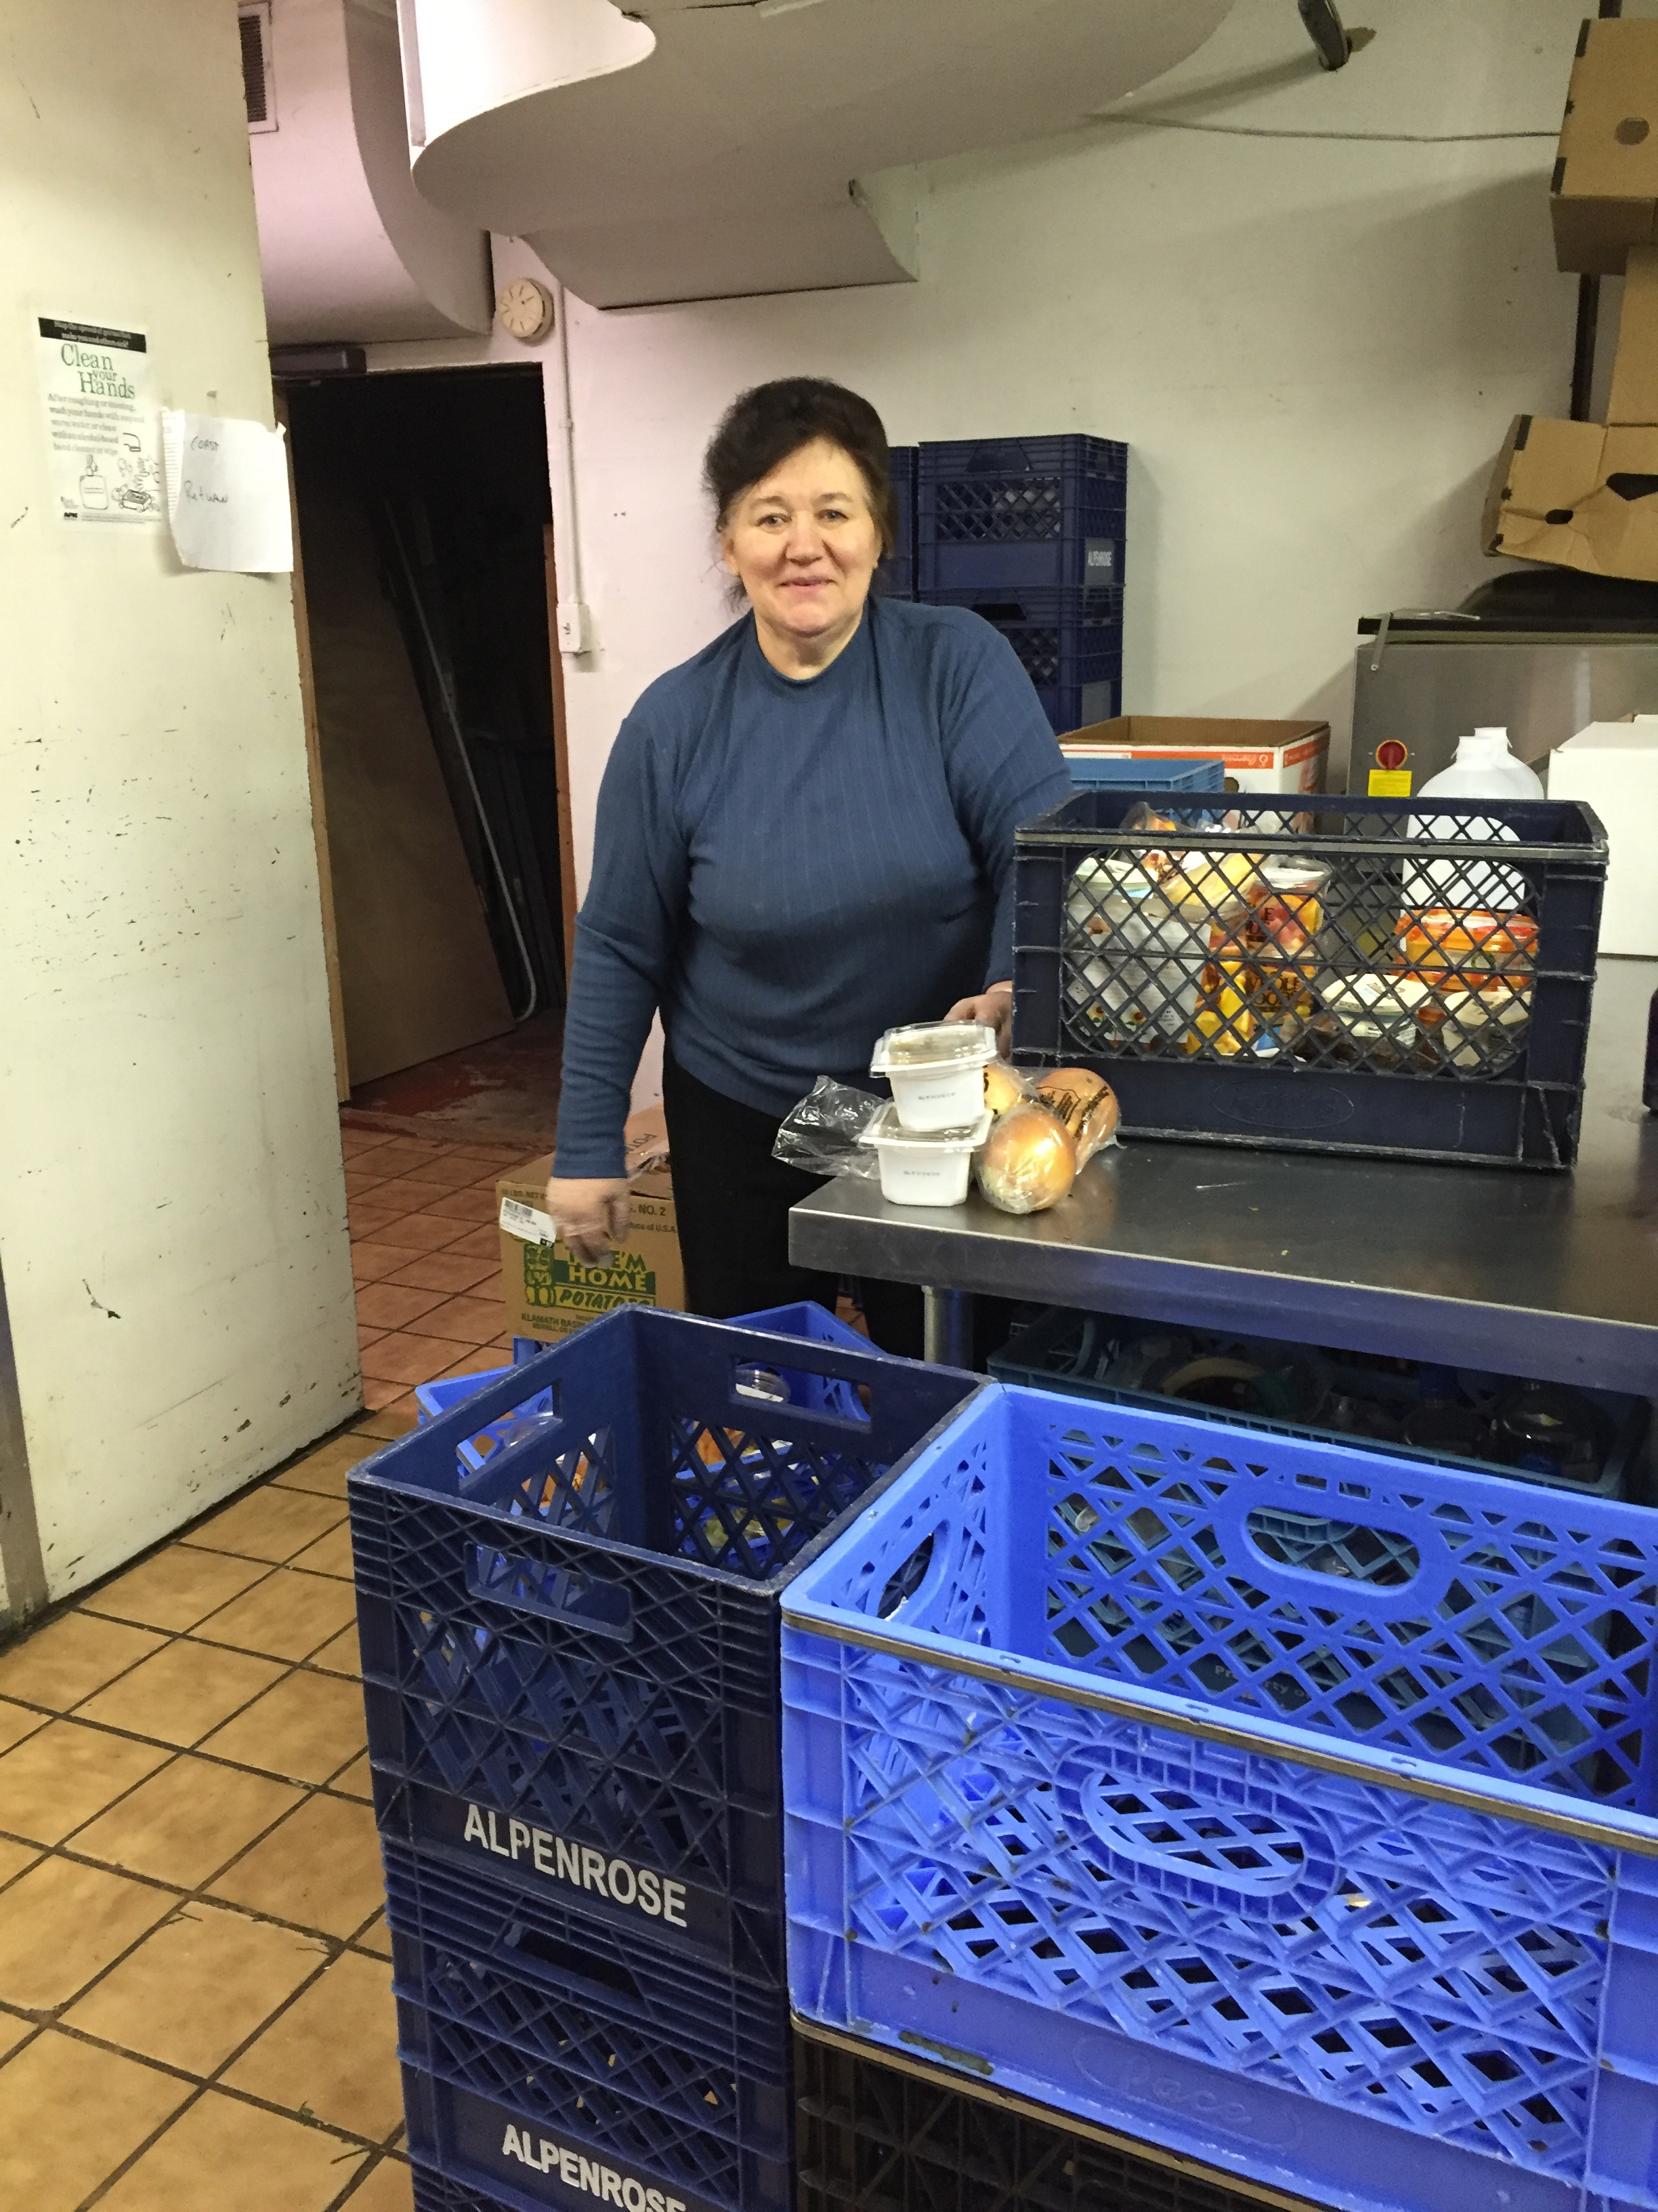
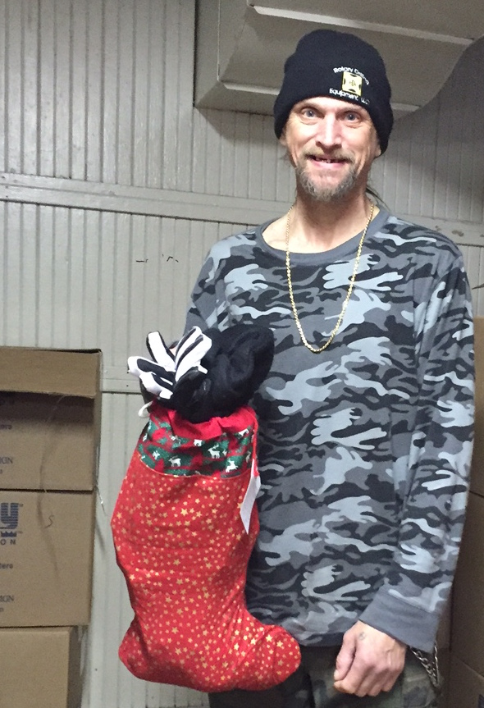

This copy belongs to: ____________________________
(This handbook was updated on April 10, 2017 – latest version can be found on cscoregon.org/volunteer)

Contents

- How to get in touch – Page 3
  - Getting started
  - Phone list
  - Who to report issues to
- How CSC works – Page 4-5
  - Mission statement
  - Organizational Vision
  - How volunteers fit in
  - Who our clients are
- Current Volunteer Opportunities – Page 6-7
- Guide to working with unhoused communities – Page 8
- Rules & Expectations – Page 9-12
  - Rules that apply to everyone
  - Volunteer-Specific Rules
  - Screening, Dismissal, Background checks
  - Child policies & Abuse prevention policies
  - Emergency Procedures
- Resources – Page 13

HOW TO GET STARTED VOLUNTEERING!

- Show up for a volunteer orientation. (available the 1st Monday and 3rd Wednesday of the month, at 9 a.m.) Let us know you’ll be coming by emailing info@cscoregon.org.
- Learn about what CSC does at the orientation!
- You will be given a list of available shifts.
- Circle the shifts you want, and the number of hours you want to do.
- You will get a call back from CSC staff within a week to schedule your first shift!
How to get in touch

Staff Member Phone numbers/email
Debra Mason, Executive Director: 503-929-1601 / debramason@cscoregon.org
Rob Shryock, Operations Manager: 503-560-6178 / robshryock@cscoregon.org
Julie Peterman, Administrative and Fundraising Assistant, 503-927-0582: juliep@cscoregon.org
Tabitha Alajmi, Food Pantry Manager: 971-312-4547 / tabitha@cscoregon.org

General email inquiries: info@cscoregon.org
Main phone number: 503-771-7914
Online: cscoregon.org
Facebook: ClackamasServiceCenter
Twitter: @cservicec
Reporting

At Clackamas Service Center, we believe strongly that if you see something, you should say something. If you are debating to yourself whether something is report-worthy, it probably is.

Should you need to make a report about a volunteer or client’s behavior (or something as simple as a spelling error on a sign) you can make a report to a staff member in person or to info@cscoregon.org, an email box shared amongst staff but not visible to volunteers.

Reports about staff behavior should be directed to CSC’s Executive Director, Debra Mason. She can be reached at debramason@cscoregon.org or 503-929-1601. Should you not feel comfortable communicating with staff, Mark Beirwagen, Board President, can be reached at beirwagenm@yahoo.com.

How CSC works
Clackamas Service Center Mission Statement
Clackamas Service Center (CSC) improves the safety, stability and health of Clackamas and Multnomah county residents by offering food and other supportive resources to reduce hunger and increase self-sufficiency. Our core values are respect, inclusion, health, community leadership, accountability, operational excellence, and sustainability.
Organizational Vision
Clackamas Service Center was founded in 1971. It was sustained early on by three women who pooled together their bingo winnings ($1000) to address a need they saw in the community. The organization was known as the Kendall Center, renamed Clackamas Service Center in 1997. Since its founding, CSC has remained a small, scrappy organization dedicated to addressing the moving target of systemic poverty and homelessness.
Individuals and families in Clackamas and Multnomah counties who may be struggling with poverty, hunger, and housing insecurity know and trust CSC as the premier hub of responsive, demand-driven services and additional supportive resources that improve safety, stability, and health as clients take steps to achieve their goals of self-sufficiency. CSC’s nimble and adaptive model leverages a lean yet highly qualified staffing structure, onsite programming and client services, mobile outreach, partners, supporters, professional networks, and volunteer resources to achieve reciprocal impact for our shared community and all who call it home. Our vision is also referred to as the “hub and spoke” (see diagram above) because we use the concept of being a hub for food to offer a variety of other supportive services.

Shape of our organization and where volunteers fit in
Clackamas Service Center relies on partners and volunteers to run or provide the work many of its services. Coordinating all of this is a small staff and a board of directors. The staff’s role is to coordinate services and troubleshoot problems, while volunteers and partnering agencies handle the day-to-day.
Most CSC volunteers assist with our food program, either with meals, food boxes, doing interviews for food box intake, or picking up donations from local grocery stores. As mentioned, the food program is central to what we do, but we also rely on volunteers to run much of the operational details with minimal staff oversight. As such, volunteers are essential to our mission – operating with relative independence, while being accountable to staff, and often serving as the “face of the organization” to clients.
Volunteers also enable CSC to expand the services we are able to provide. At CSC, volunteers provide haircuts, help with local homeless outreach, support programs like Community Basket, and assist in operation of the shower cart.
Overview of our clients:
Clackamas Service Center serves a variety of clients. We serve many unhoused clients but this is not the only group we serve – most of our services are open to anyone. Many clients use services like food boxes or the clothing room to help defray expenses and keep themselves in housing.
Most of our clients have very low income. 42% have no source of income at all. 70% make less than $99 a n month. Only 5% have full-time employment. CSC is not unique in this respect - 4% of American families (1.5 million households) live on $2 a day or less.
Our clients don’t all have one story. People struggle with poverty for a variety of reasons. Some may lose a job, then their apartment, and find themselves homeless. Others may be fleeing domestic violence. Still others may be struggling with addiction. When working with our clients, start by listening and not making assumptions about why they need our services. Asking for help is often embarrassing and difficult, and we want to create a compassionate, supportive environment for clients.
Other facts about CSC clients:
- 15% of our clients self-identify as having a physical disability. 37% have Medicaid.
- 61% of our clients have food stamps in addition to getting food at CSC.
- Although you don’t often see kids at CSC, 26% of people who benefit from our food boxes are under 18.

Current Volunteer Opportunities
This is a short list of current volunteer opportunities. Full job descriptions are available on request by emailing info@cscoregon.org.

Food Operations Volunteer Roles

Cooking Meals

Description: Help prepare and serve a nutritious and filling meal for 50-120 people and clean up afterwards. The ideal volunteer knows their way around a kitchen, but more importantly, is diligent, detail-oriented, and committed to providing people experiencing homelessness with good, nutritious food and kindness. This shift is about 4 hours long.

You do NOT need a food handlers card, but must complete a short (14 minute) Oregon Food Bank training, and confirm to the volunteer coordinator that you did so.

Serving Meals

Description: Help serve a nutritious and filling meal for 50-120 people and clean up afterwards. The ideal volunteer is personable and interested in serving people. This is a great opportunity for groups and lasts 1.5-2 hours.

You do NOT need a food handlers card, but must complete a short (14 minute) Oregon Food Bank training, and confirm to the volunteer coordinator that you did so.

Food Box Preparation & Recieving

Description: Our food box crew helps turns thousands of pounds of uncategorized donations into up to 15-40 custom-made, healthful food boxes a day for people living in poverty. Tasks include receiving and sorting donations, assembling food boxes, and cleaning. Ability to lift 30 lbs preferred. Shifts can be 2.5-6 hours.

Donation Pick-Up Driver

Description: Pick up donations from local grocery stores and food sources and bring them back to CSC using CSC’s cargo van. Requires driver’s license, ability to lift 30 lbs., ability to drive cargo van, and successful completion of MVR check. Shifts are 1.5-4 hours.

Data Entry

Description: Assist with entering CSC data into our system, Service Point, as well as clerical and filing tasks. Shifts are 1.5 hours or more.

Direct Service Volunteer Roles

Front Desk

Description: Front desk volunteers are at the front lines of CSC – they conduct food box interviews, help clients access services on and offsite, and take the lead on basic administrative tasks including answering phones. This is the ideal task for somebody seeking a substantial, involved opportunity in the social services world. Shifts can be 2-4 hours, plus additional mandatory monthly meeting (one hour)

Shower Monitor
Description: Provide 6 people with access to hot showers every hour, helping maintain the wait list, ensuring that operations go smoothly, and helping with set up and take down. Shifts are about 3 hours.

SNAP Outreach

Description: SNAP Outreach volunteers focus on providing food stamp access for people in need, helping them with applications and answering questions about SNAP, as well as helping them navigate the system of services more generally. Shifts are about 3 hours.

Hospitality

Description: Hospitality volunteers help keep CSC a safe, supportive place by creating a positive environment – greeting clients, talking to them, playing games with them, etc. Shifts can be at a length that fits your availability.

Volunteer Hairstylists

Description: Provide volunteer haircuts to people in need. Haircuts help improve our client’s self-esteem and increases their ability to access services and employment. Must be a licensed hair stylist. Shifts are 2 hours or more.

Working with Unhoused and Housing-Unstable Clients

All of CSC’s volunteer positions involve at least some direct interaction of clients. Volunteers should expect this as part of the work. Working with people with a high incidence of drug addiction, mental illness, homelessness, and extreme poverty is not always easy, but it also is rewarding – and safe – if you follow a few simple guidelines.
- Be Kind, Respectful, and Straightforward (aka. Be yourself)
We call the people we work with “clients”, and in that vein, you want to provide good “customer service.” What does that mean?
- Be kind and respectful, trying to meet client’s needs as thoroughly as possible. This kind of attentive, professional behavior helps clients feel valued and humanized.
- Don’t overpromise – we can’t fix everything that’s wrong with people’s lives.
- Be honest with people about what you do and don’t know – you can always ask staff questions if you don’t know the specifics about a given service!

- Create good boundaries for yourself, and respect others’ boundaries.
Unlike in customer service, you can always feel free to say “no.” Assert the difference between what you can help people with and what you can’t. You don’t have to make a pot of coffee just because a client asks you for coffee, for example.

Respect the boundaries set up by others, both physical and emotional – don’t force people to engage with you in a way they are uncomfortable with.

- Remember that you are a small part of your client’s life. (Don’t be a superhero)
Our clients often have such large, complex, and seemingly unfair problems that it can be tempting to try to help everyone with everything they ask for, to go above and beyond for everyone, to take on the pain of other’s as your own.

This can lead to what is called “Vicarious Trauma”, when you become so involved in someone else’s trauma that it also impacts you. Remember that there is a whole community of service providers out there to help people. Don’t try to be a superhero – being competent, helpful, and compassionate is enough.

- If it makes you uncomfortable, report it. (If you want)
At CSC, if somebody’s behavior is making you uncomfortable – if they are calling you names or racial slurs, treating you aggressively, etc. – please report this to staff immediately so we can respond appropriately. Helping guide our clients through what behaviors are acceptable and what are unacceptable is a service to them in the long run.

- Follow the Rules…. (Read on)

Rules and Expectations

Rules that apply to everyone (clients and volunteers)

Clackamas Service Center does not allow:

- Drugs or drug use on the property, including marijuana and alcohol.
- Buying or selling anything on center property.
- Off-leash animals anywhere.
- Any animals in the dining hall, except service animals.
- Threats; violent, loud, or discriminatory language.
- Fighting or violence.
- Any action that creates an unsafe environment.
- Littering or abandoning property. Anything left unattended anywhere, including on neighboring property, may be thrown out.
- Trespassing, including: being here after hours, sleeping on property, going downstairs or in the kitchen without permission, going behind the medical van.
- More than one person at a time in the bathroom.
- Harassing CSC’s neighbors, sleeping, littering, or using drugs on their property or on Cornwell Street.
Community Responsibility:
If violations of rules become so troublesome in a short period of time that it affects the operations of CSC, the center may close to the public for a short period of time to address these issues.

Volunteer-Specific Rules

0. CSC staff reserves the right to terminate your volunteer status at CSC at any time for any reason for any length of time. You are an-at will volunteer and may discontinue volunteering at any time.
1. The same rules that apply to the clients apply to you.
2. No taking advantage of your position as a volunteer to favor certain clients. (see discrimination policy)
3. You may use any client service as long as you go through normal processes. Please give priority to clients first for using services. Please ask a staff member before taking food for any reason.
4. Don’t be in the volunteer or staff space when you are not on shift unless you have a specific reason. (I.e. meeting with staff member)
5. Please wear closed-toed shoes or boots, and appropriate clothing.
6. Please provide notice if you are unable to make a shift, or unable to volunteer in the future.
7. Don’t intervene in arguments or fights between clients or between clients and volunteers, instead find a staff member, or call 911 yourself if appropriate.
8. Don’t touch clients without their permission (even a hug – just ask first!)
9. Please respect confidentiality of client information in the CSC database as well as personal information shared with you be clients.
10. All volunteers must treat with professionalism and respect all clients, volunteers and staff of the CSC.

Community-Service Specific Rules

All volunteers using time at CSC towards their community service hours are expected to show up on time, during their scheduled shifts. They are also expected to stay on task and do their best work when they are here, and meet the basic standards of behavior one would have to meet in a workplace - including but not limited to –
- Staying in their volunteer area except during breaks.
- Staying on task – not being on their phone, texting, playing games, etc.
- Putting in effort, doing a reasonable amount of work.
- Following the instructions of staff.
- Treating clients and other volunteers (including community service workers) with respect.

Failure to follow these rules may result in us terminating your community service at CSC.

Screening, Dismissal, and Background Checks
In the course of some volunteer roles, CSC may require background checks. We recognize that many of our volunteers are in recovery and may not have a perfect record. However, any volunteer found to have a sex offense on their record will not be allowed to volunteer at CSC in any capacity (even for roles that do not require background checks)

Harassment, Discrimination, Child, and Abuse Prevention Policies

Harassment
Clackamas Service Center is committed to the idea that volunteers, staff, and clients have the right to access CSC’s service in an environment free from discrimination or harassment.

Harassment includes any unwelcome or unwanted advances, including sexual advances, unwelcome requests or demands for favors, verbal abuse or teasing, or creating a intimidating, hostile, abusive, or offensive work environment.
Please report harassment or discrimination as detailed on page 3. Discrimination can also be reported to the USDA (see below)

Discrimination
In accordance with federal law and US Department of Agriculture policy, this institution is prohibited from discriminating on the basis of race, color, national origin, sex, age, or disability.

To file a complaint of discrimination, write USDA Director, Office of Civil Rights, 1400 Independence Avenue, SW, Washington, D.C., 20250, or call 800-795-3272. USDA is an equal opportunity provider and employer.
Child & Abuse Prevention Policies
CSC considers it essential to our mission that children volunteering or visiting CSC are safe. Minors volunteering at CSC must have a parent, guardian, or person serving in loco parentis sign their volunteer waiver. Minors under 16 must volunteer with a parent, guardian, or person serving in loco parentis.

Accompanying Children: Adults serving with a minor must accompany them into any room they go into, excepting the restroom. Minors should never be alone with one adult in a space unless there is regular supervision of staff or regular individuals from the public entering the space.

Boundaries: Adults should observe and model clear boundaries with children. Any time of inappropriate conduct with children (teasing, harassing is grounds for dismissal.

Reporting: Any inappropriate conduct (on any matter) should be reported to staff, as detailed on page 1. As an organization that works with many vulnerable people, including seniors and the mentally handicapped, we are committed to address all forms of harassment and predatory behavior.
Sex Offenses: As detailed in our background check policies, no person convicted of a sex offense shall volunteer at CSC. (Though it should be noted not all volunteers are background checked, see “Screening, Dismissal, and Background Checks”)

Emergency Procedures

Client is aggressive, threatening, or violent
There are many sorts of “aggressive client” situations. If a client is being aggressive towards you or others, we prefer that you find a staff member or security volunteer. We are trained in conflict resolution, know the clients, and can mediate situations. This can be accomplished by pressing the “panic” button or finding us in an office.

If the situation is one that may create an immediate threat to somebody’s safety (i.e. somebody brandishing a knife at somebody else) consider calling 911 immediately. Please note that if an aggressive person notices you calling 911, they may direct aggression towards you - it is best to be at a distance and have “backup”. Generally if a person is aggressive, it is safest to keep your distance, avoid making eye contact, stand at a 45 degree angle to the person, and generally communicate that you are non-threatening.

Client is unresponsive / not breathing
If a client is nonresponsive and not breathing, it is imperative that 911 be called as quickly as possible AND that CPR be started. Just doing CPR is useless if 911 is not called. Many of our staff and volunteers are CPR trained. Outside In may be contacted, but they are NOT an emergency services provider and should not be considered a substitute for 911.

Client nonresponsive in bathroom or shower unit.
If a client is nonresponsive in the bathroom, it is a possibility someone has overdosed. People can die in minutes of an overdose. Inform staff immediately, staff members have a key to the bathroom; there is also a “key baton” in the kitchen. If the person is unconscious, call 911 as soon as possible. Outside In may be contacted, but they are NOT an emergency services provider and should not be considered a substitute for 911.

Fire in the kitchen
In the event a fire breaks out in the kitchen, active the wet chemical surpression system and try to put it out, turn off the gas if possible, and use the fire extinguisher to attempt to control the fire. Call 911 if the fire is not put out immediately.

Involving Outside In in emergencies
Outside In provides medical primary care services to anyone in need. They do a “triage” system so the highest-need clients are seen first. This means non-urgent issues may take a while to address. Excluded clients can still see Outside In downtown unless Outside In also bans them. Outside In is a primary care facility, emergency issues should be handled by an emergency room, not by Outside In, unless the person’ life is in immediate danger.

Learning more about CSC’s resources

All of CSC’s resources are listed in our bulletin, published monthly or more often. Bulletins are usually available at the front desk, ask Rob if we are out. The most complete description of our services is available on our website, at cscoregon.org/services. We recommend every volunteer take time to review the many resources at CSC.

Community Resources

Where to find resources
Rose City Resource Guide - Available typically at the front desk.
Clackamas County Community Resources – One pager list of Clackamas County Resources. Available often at the front desk or by googling “Clackamas County Community Resources”
CSC Quick Screen – Available at the front desk.
211 Info – 211info.org or by calling 211 (or text 898211)

Training Resources
Deesclation Training – Rightresponse.org
Domestic Violence Response Training – Cwsor.org ($)
Free Mental Health Training - https://www.gettrainedtohelp.com
Guide to using Macs for Windows Users - http://www.makeuseof.com/tag/quick-guide-using-mac-windows-users/
Oregon Food Bank Food Safety Video - https://www.youtube.com/watch?v=0vE_lloeAy8&feature=youtu.be
Additional food training pamphlet – Available from Volunteer Coordinator upon request
Volunteering with Chronically Homeless Individuals Toolkit - http://www.handsonnetwork.org/files/resources/toolki_chronically_homeless_9july13.pdf

